Discussion

Robustness to Synthetic Generative Model Misspecification
Tien Tyler Le
09/28/2026

The production JITAI decision engine gate prompts on an expanding within-person 80th percentile of observed MSSD. By definition, an expanding quantile window weights every observation a participant has ever generated equally forever. This architecture implicitly embodies an invariant generative assumption: latent affective volatility and autocorrelation represent fixed, stationary personal traits calibrated during an initial run-in period.

In live mHealth cohorts, latent dynamics are rarely stationary. Exogenous shocks, clinical decompensation, intervention habituation, and recovery systematically shift volatility profiles over time. To examine what breaks when this stationary generative assumption fails, and how gracefully the decision engine degrades, we evaluated the decision engine alongside a 7-day rolling-window diagnostic contrast and exponentially moving quantile (EMQ) architecture across controlled non-stationary regimes (150 synthetic participants x 10 replications, 35 days, 5 EMAs/day).
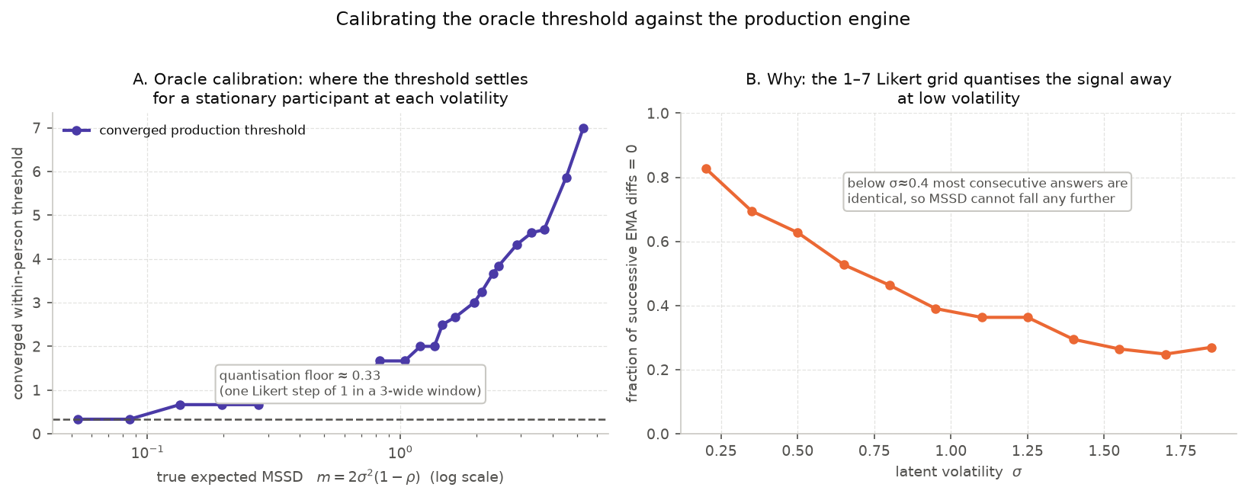
Figure 1: Empirical oracle threshold calibration and bounded scale quantization floor. (A) Median converged within-person 80th-percentile production threshold as a function of latent expected instability m = 2σ²(1-ρ) (log scale) for stationary synthetic cohorts. (B) Fraction of successive EMA differences equaling zero across latent volatility σ.

The Mechanics of Adaptation Failure
When latent dynamics diverge from a stationary AR(1) path, the production threshold anchors to historical regimes that no longer exist. The nature of the resulting failure depends entirely on the direction of the regime shift:

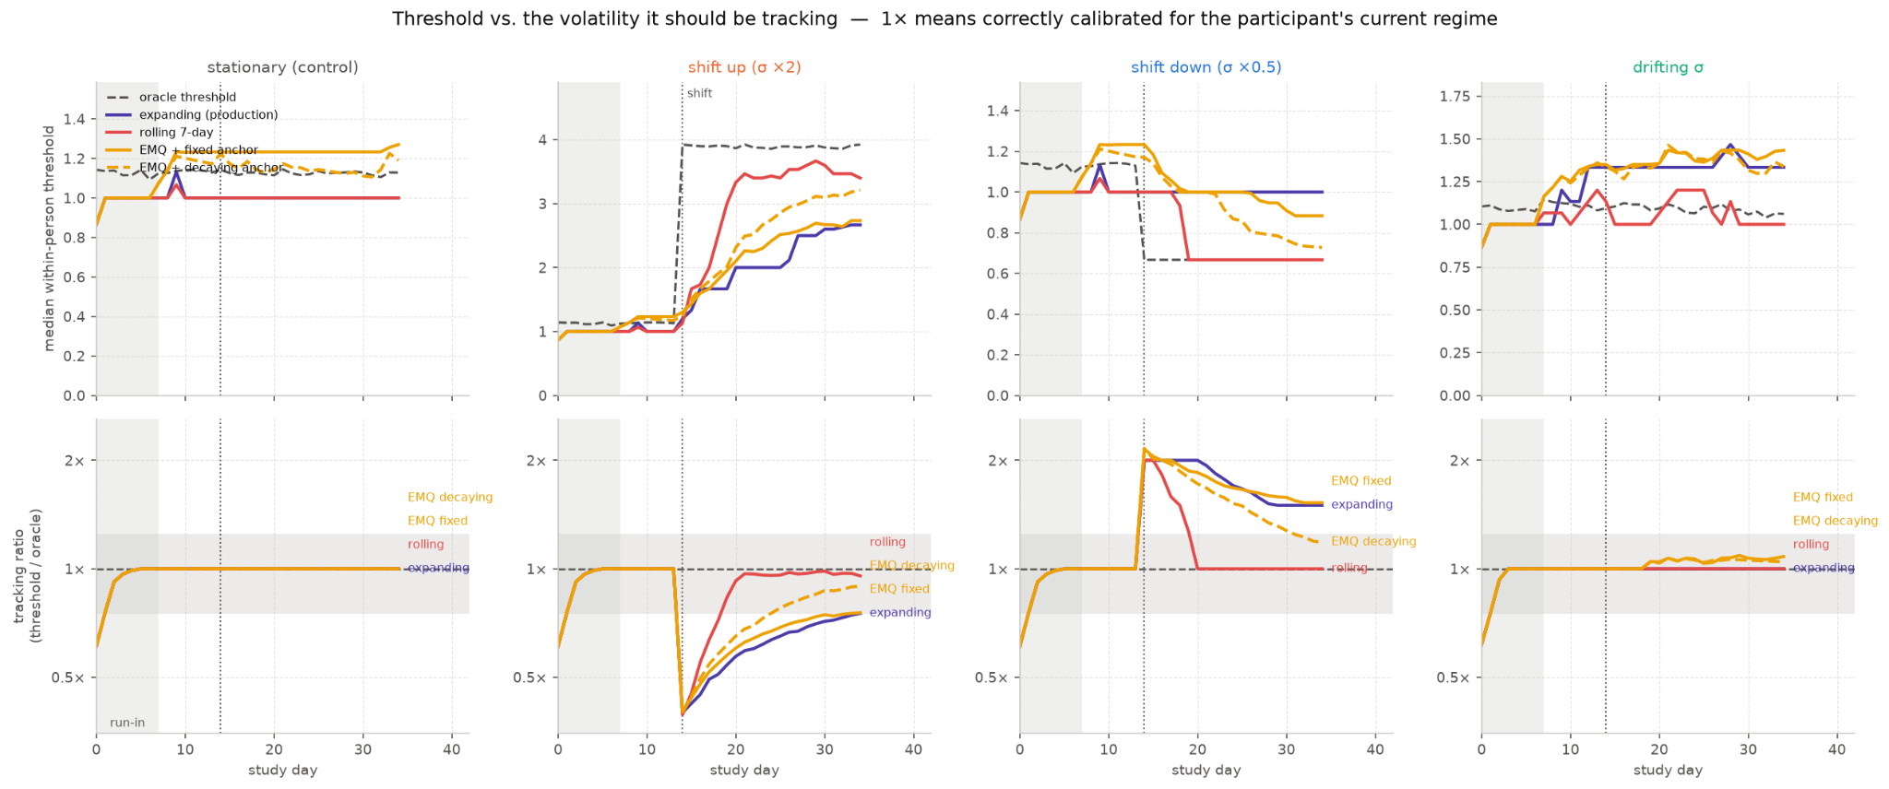
Figure 2: Within-person threshold tracking and adaptation latency across stationarity scenarios. Top row: Median within-person threshold trajectories over the 35-day study period across four latent volatility regimes (stationary control, shift-up σ × 2, shift-down σ × 0.5, and drifting σ, with regime transitions at day 14) for the expanding production engine, 7-day rolling contrast, and exponentially moving quantile (EMQ) arms. Bottom row: Tracking ratio (threshold / oracle threshold) over study days, where 1.0× (dashed line) denotes correct calibration for the participant's active regime. Shaded bands indicate the initial 7-day run-in window and the ±25% tolerance boundary. The expanding production threshold exhibits permanent hysteresis under structural shifts, falling to 0.62× immediately after a shift-up (recovering only to 0.74× by day 35) and overshooting to 1.71× following a shift-down (settling at 1.50× at study end).

Asymmetric Tracking and Latency
Following an abrupt doubling of volatility at day 14, the expanding threshold fails to keep pace with the true data-generating process. Immediately post-shift, the tracking ratio (production threshold divided by the empirical oracle threshold) collapses to 0.62. Because historical low-volatility observations dilute the expanding buffer, the production threshold never fully readapts within the 35-day trial, recovering only to a ratio of $0.74$ by study end. Conversely, when volatility halves at day 14, the expanding threshold overshoots to a tracking ratio of 1.71 post-shift and settles at 1.50, remaining 50% too conservative indefinitely.

Contrasting Memory Architectures
The 7-day rolling window diagnostic contrast discards observations outside a 35-prompt trailing horizon, fully recalibrating to within 25% of oracle calibration in 5 days during a shift-up and 6 days during a shift-down. However, this agility incurs a steep cost: trailing rolling windows suffer from small-sample variance under stationary conditions, doubling threshold volatility (0.030–0.040 vs. 0.010–0.014 for the expanding baseline) and introducing spurious prompt fluctuations.

Detection Performance and Dosage Distortion
Scoring true-positive rates (TPR), false-positive rates (FPR), and precision directly on threshold crossings—unconfounded by cooldown windows or daily dosage caps—reveals substantial operational divergence across non-stationary arms:

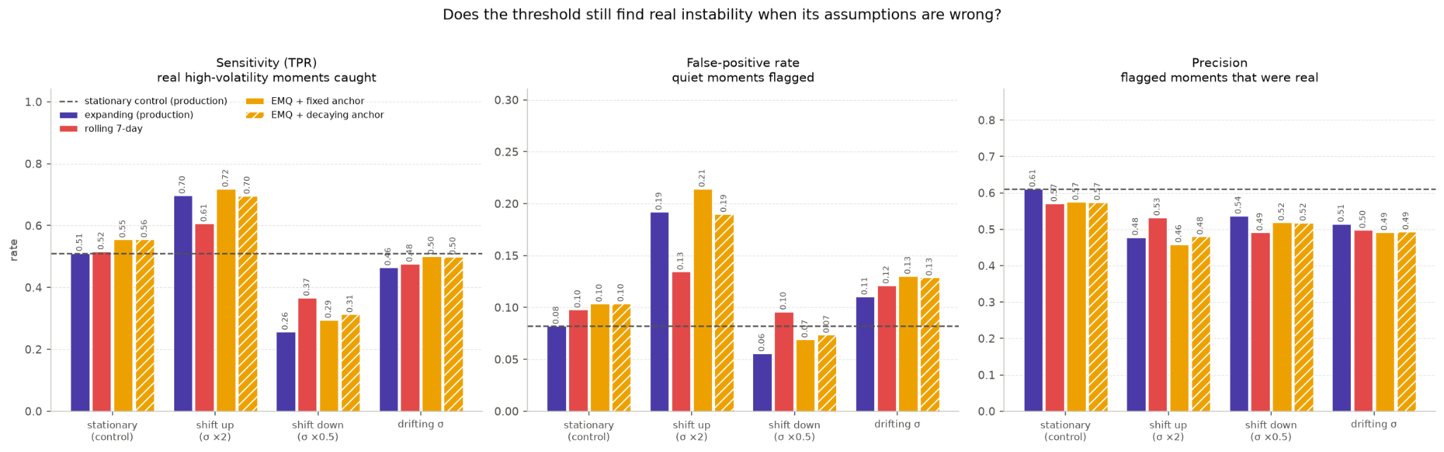
Figure 3: Detection performance of threshold crossing rules under generative model misspecification. Sensitivity/True-Positive Rate (TPR, left), False-Positive Rate (FPR, center), and Precision (right) are scored strictly on raw threshold crossings without contamination from daily prompt caps or refractory cooldown timers. Ground-truth high-volatility moments are defined as the upper 20% empirical quantile of standardized latent instability within each participant's active regime. Dashed reference lines mark stationary control performance (TPR = 0.511, FPR = 0.082, Precision = 0.611). Under an abrupt rise in volatility (shift-up), the production threshold becomes overly permissive (TPR = 0.697, FPR = 0.192, Precision = 0.478). Under a drop in volatility (shift-down), sensitivity collapses (TPR = 0.256) due to silent intervention withdrawal.

Elevated Volatility (Shift-Up Regime)
Under a doubling of volatility, the production threshold becomes excessively permissive. Post-shift sensitivity rises to $TPR=0.813$ (overall $TPR=0.697$), but FPR more than doubles to $0.192$ (post-shift $FPR=0.244$), causing precision to fall to $0.478$ compared to the stationary baseline of $0.611$. Prompt dosage increases from 4.59 prompts/week under stationary control to $9.21$ prompts/week post-shift, exceeding IRB Protocol Section 7 projections and risking severe participant alert fatigue.

Calming Regimes (Shift-Down Regime)
The failure mode under decreasing volatility is silent and substantially more severe. As the threshold anchors to historical high-volatility inputs, sensitivity collapses to $TPR=0.256$ overall and down to $TPR=0.103$ post-shift. Prompt delivery drops to 1.02 prompts/week (a 78% reduction from baseline), virtually silencing the intervention and causing the engine to miss genuine acute spikes relative to the participant's calmer baseline. This silent intervention withdrawal represents a direct protocol violation relative to IRB Protocol Section 7 expectations.

Continuous Volatility Drift
When latent log-volatility follows a mean-reverting random walk ($ϕ=0.97$), the production engine degrades gracefully. Because continuous drift lacks a sharp structural breakpoint, the expanding threshold tracks the regime median with minimal bias (overall $TPR=0.464$, $FPR=0.110$, tracking ratio settling at $1.00$), demonstrating robustness to smooth non-stationarities.

Likert Discretization and Algorithmic Design Trade-Offs
Ground-truth evaluation requires distinguishing algorithmic tracking failure from scale quantization artifacts. On bounded Likert scales, successive EMA responses from low-volatility individuals ($σ<0.4$) frequently land on identical integers, causing up to 83% of consecutive differences to equal zero. This creates an irreducible quantization floor at an observed MSSD of approximately $0.33$ (one step squared in a rolling window of 3). Linear references misinterpret this measurement floor as severe tracking bias, whereas calibrating against an empirical oracle demonstrates that the production engine correctly absorbs scale granularity.

Furthermore, because the gate rule specifies ${\hat{MSSD}}_{t}≤Threshold_{t}$ as blocking prompt generation, exact ties suppress triggers. Under stationarity, discrete ties account for 11.6% of evaluable prompts. Consequently, an 80th-percentile threshold yields an empirical crossing rate of 16.8%, sitting strictly within the discrete quantile bracket. This Likert tie suppression substantially reduces available randomized decision points across the trial.

While a trailing 7-day rolling window resolves hysteresis under structural breaks, deploying it into production would exchange silent under-detection during recovery for elevated false-alarm rates during quiet periods. Exponentially moving quantile (EMQ) architectures with decaying anchors provide a middle path, recalibrating in 10 to 17 days while stabilizing the burn-in period.

Implications for Trial Statistical Power
The combination of non-stationary volatility shifts and discrete Likert tie suppression directly degrades trial statistical power. To preserve intended statistical power and maintain planned intervention dosage under real-world non-stationarities, threshold recalibration to the 70th percentile is recommended, alongside re-estimating effect sizes to target a minimum detectable effect size (MDES) of d = ( 0.20 - 0.25).

